NAME: _______________ Date ________________
CHANGES OF STATE WORKSHEET

Vocabulary
Condensation Melting
Deposition Solidification
Evaporation Sublimation

Use the terms in the vocabulary box to label the diagram. Place the terms on the numbered arrows.

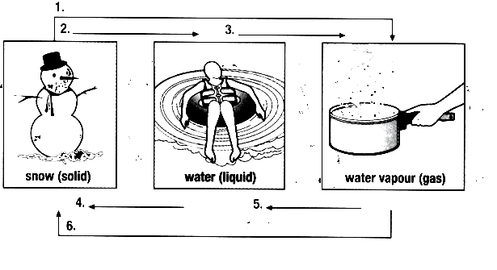

7) Complete the following table by describing the change of state. The table has been partially completed to help you.

 | Change of state | Heat added or released
Condensation |  | Released
Deposition
Evaporation | Liquid →Gas
Melting  (Liquidefacation) |  | Added
Solidification
(Freezing)

Sublimation

8) Match each Description on the left with the correct change of state on the right. You may use some changes of state more than once.

Term |  | Descriptor
 | Ice is left out on the counter | A. | Sublimation
 | Frost forms on the window on a cold day | B. | Condensation
 | Water is left in a freezer | C. | Evaporation
 | Clothes are left out to dry | D. | Deposition
 | Dry ice is used to create fog | E. | Melting
 | The bathroom mirror gets fogged up after a shower | F. | Solidification
 | A pond gets shallower at the end of a long hot summer
 | Your hair was wet when you left the house, but dries by the time you get to school
 | The ice cream you are eating drips down your arm
 | A full pot of soup fills only half of the pot after summering for 2 h
 | Liquid glass cools and hardens
 | A cold drink is wet on the outside of the glass

9) What is the difference between heat and temperature?

10) How does matter change from one state to another?

11) What is the relationship between the amount of space between particles and the state of the matter?

12) How is melting similar to solidification?
How is it different?

13) In which sample do molecules have the greatest average kinetic energy?
A. He at 100K B. H2 at 200K
C. O2 at 300K D. H2O at 400K

