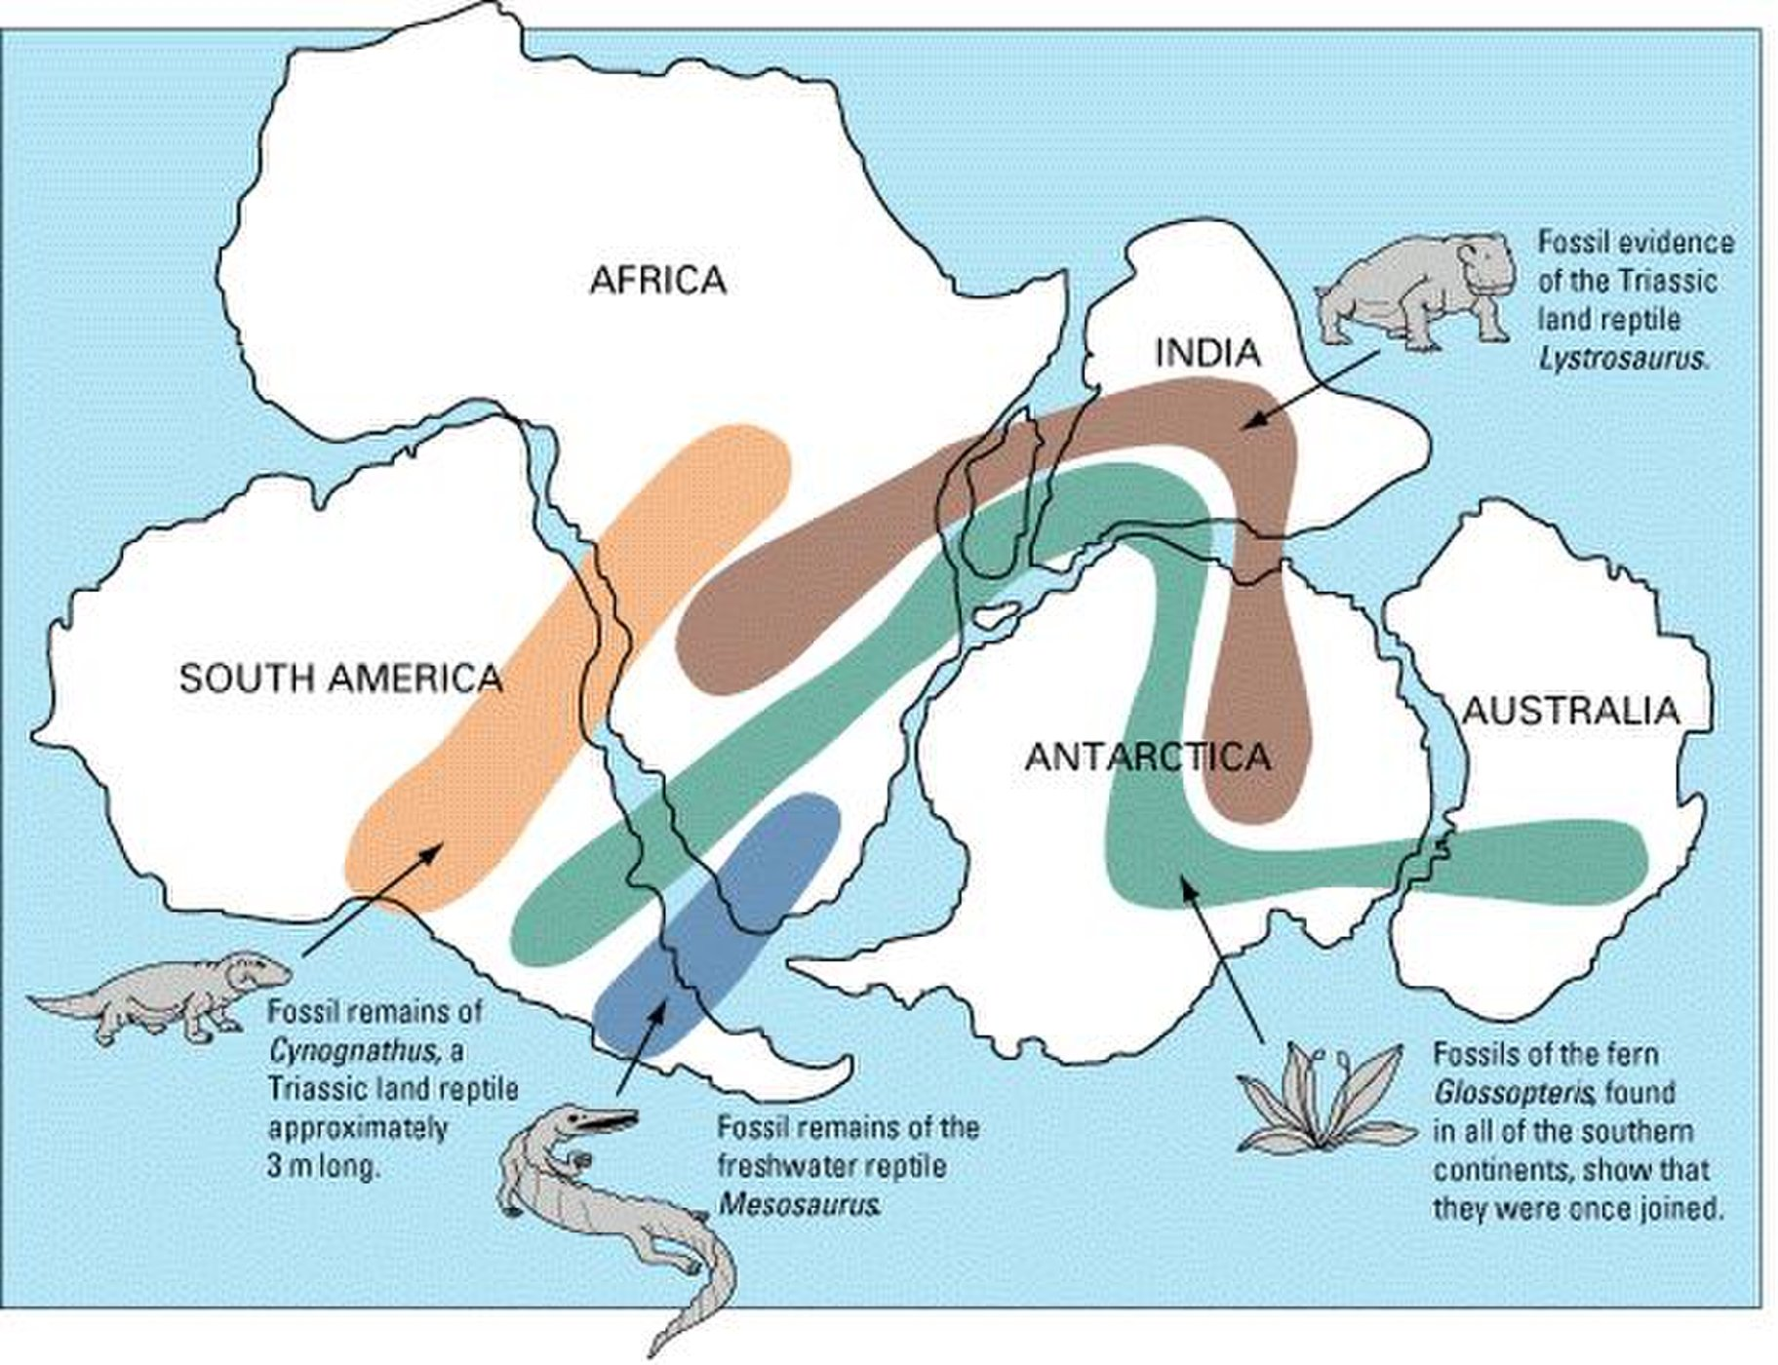
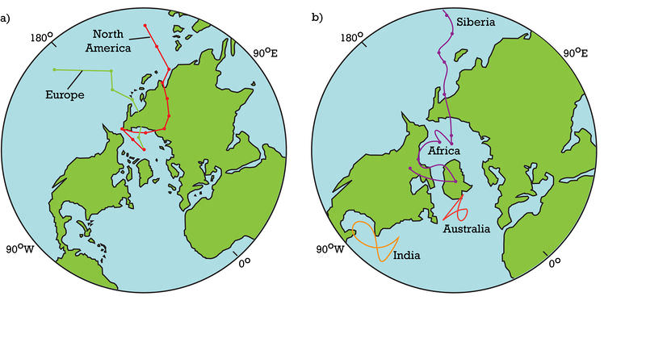
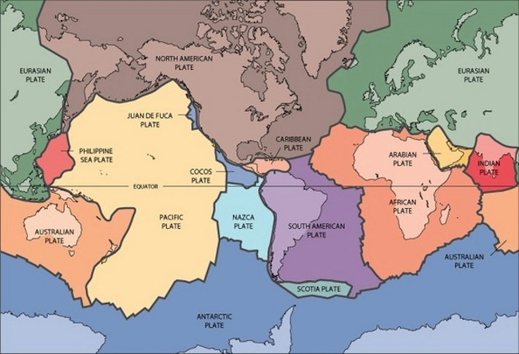

Continental Drift:
Wegener – scientist who compared rocks and fossils on different continents to propose a theory that the continents moved over the water.
Wagner used evidence such as:
The mountain range in North America matched a mountain range in Africa. Rocks that were side by side were now on different continents.
Remains of a Mesosaurus was found in both South America and Africa.
Lystrosaurus fossil remains were found in South America, Australia, Africa and India.
Glacial deposits in South America, Antarctica(South Pole), India, Africa and Australia.

When Wegener proposed continental drift in 1912, many geologists did not agree. They thought Earth's incredible mountains were created because our planet was cooling and shrinking since its formation, Frankel said. And to account for the identical fossils discovered on continents such as South America and Africa, scientists invoked ancient land bridges, now vanished beneath the sea.
Researchers argued over the land bridges right up until the plate tectonics theory was developed, Frankel said. For instance, as geophysicists began to realize that continental rocks were too light to sink down to the ocean floor, prominent paleontologists instead suggested that the similarities between fossils had been overestimated, Frankel said.
Before the constriction theory, many thought that the world's formations were caused by a worldwide flood. This theory is called catastrophism, according to the USGS.
Although Wegener's "continental drift" theory was discarded, it did introduce the idea of moving continents to geoscience. And decades later, in 1960, scientists would confirm some of Wegener's ideas, such as the past existence of a supercontinent joining all the world's landmasses as one.
Pangaea was a supercontinent that formed roughly 200 to 250 million years ago. Magnetic field evidence in rocks(magnetic force surrounding a magnet) helped to prove the theory of Plate Tectonics. As magma cools, it gets a magnetic field that lines up the Earth’s magnetic field. This shows scientists the direction it was facing when first cooled.

